Welcome To…
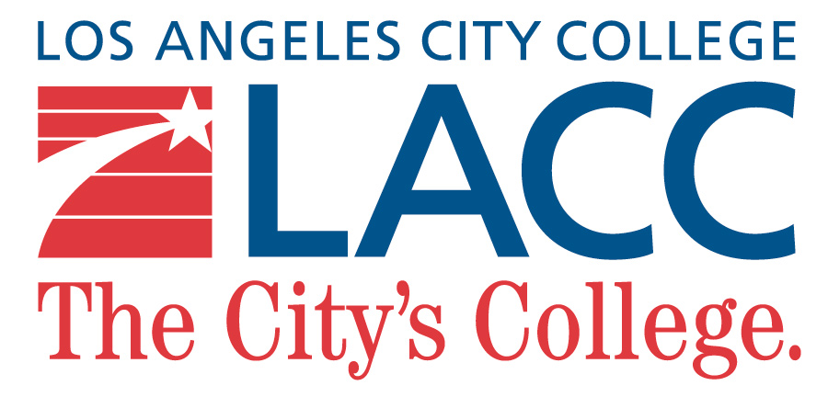
We Are So Happy To Have You Here!

Let Us Show You How To Be A Productive And Successful International Student At LACC’s Global Family

So to begin, for any question, doubt, resolution and problem, the ISP Office is your safe bet, always.

(VIRTUAL ZOOM) INTERNATIONAL STUDENT ORIENTATION SCHEDULE
Wednesday, January 20, 2021

Time | Session | Presenter | Description
3:30pm | Check-in Begins | George | You MUST, type your Legal First and Last Name into the CHAT to check-in.
3:35pm | Welcome/  Overview/  Staff Introductions | Darren | Associate Dean of Academic Affairs address new students. Staff introductions and  the ISOP agenda will be shared.
3:40pm | Ice Breaker | Darren
3:45pm | F-1 Visa - Maintaining Your Status | Marine | Learn about important immigration and academic information that you must know as an international student at LACC. The F-1 Agreement must be signed to complete orientation.
4:30pm | Website Overview | George | Review where to find forms, learn about important activities, and discover useful web links.
4:45pm | Counseling Overview | Keika | Review information from the online orientation and become better acquainted with course scheduling.
5:30pm | Student Health Insurance | Darren | Learn about how to use your student health insurance on campus.
5:45pm | Q&A | Darren
6:00pm | End

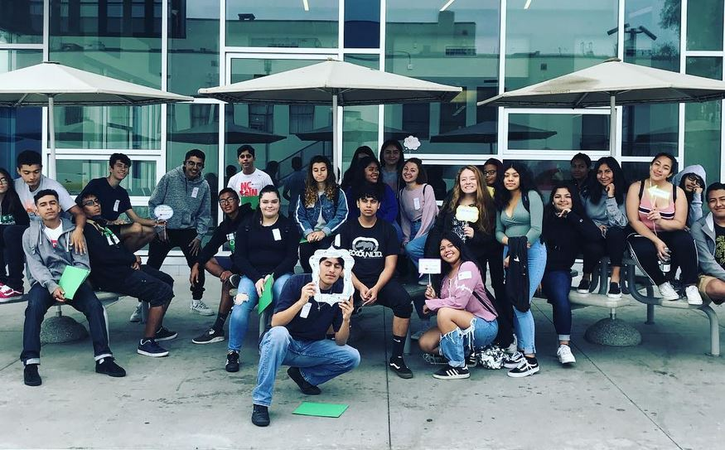

Virtual Campus Resources

Click the tutoring program for hours and location. Information may change without prior notice.

LIBRARY
Chat with a Librarian 24/7, Online Library Search (https://www.lacitycollege.edu/Resources/Library/MLK-Library-Home)

STUDENT SERVICES
CAREER CENTER: engage, educate and assist students to thrive and successfully contribute to today's economic workforce
(https://www.lacitycollege.edu/Resources/Career-Center/Department- Home)

SCHOLARSHIPS: Scholarships are gifts awarded to students offered through community groups, individual donors, and foundations, such as the LACC Foundation. (https://www.lacitycollege.edu/Admissions/Financial- Aid/Scholarships)

TRANSFER CENTER: help you prepare to transfer through workshops, activities, events, and advising (https://www.lacitycollege.edu/Resources/Transfer-Center/Department- Home)

OFFICE OF SPECIAL SERVICES (OSS): OSS facilitates equal access for LACC students with disabilities to participate in educational programs, services, and campus activities through appropriate and reasonable academic adjustments. (https://www.lacitycollege.edu/Resources/Office- Special-Services/Department-Home)

RALPH BUNCHE SCHOLARS PROGRAM: The Los Angeles City College Ralph Bunche Scholars Program provides a comprehensive and diverse educational experience with the purpose of training scholars poised to become leaders in their respective endeavors and careers. (https://www.lacitycollege.edu/Academics/Ralph-Bunche- Scholars/Department-Home)

The Writing Center and ESL Lab: offers online support for all writers on campus with one-on-one tutoring for ALL students enrolled in any English or ESL class. (https://www.lacitycollege.edu/Departments/English- ESL/Labs-Support-Services)

THE WRITERS' BLOCK: The Writers’ Block offers online support for all writers on campus with one-on-one tutoring, faculty-led workshops, and our writing-skills software program, LaunchPad. We’re here to help you with your writing assignments and your writing confidence. (https://www.lacitycollege.edu/Resources/Writers-Block/Department- Home)

Overall, we hope you enjoy & grow with your experience at LACC, even during special times like these. We can’t wait to soon be able to get to this again…

Thank You, & See You Soon!
International Students’ Services

